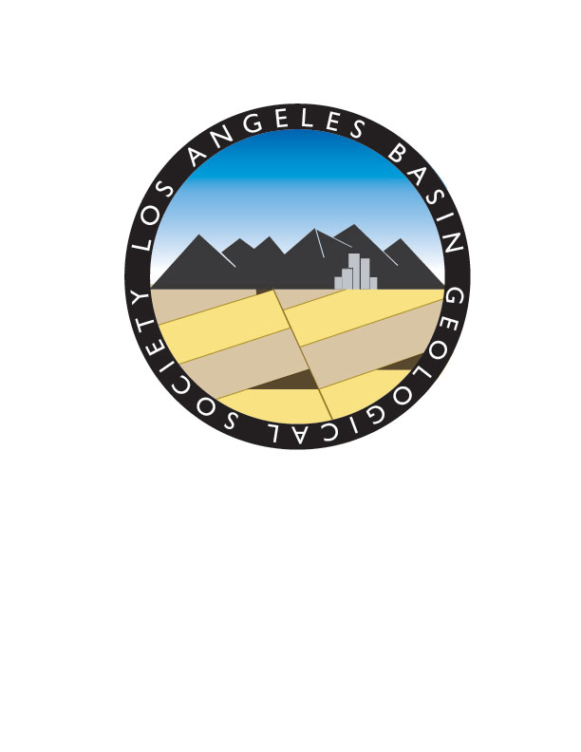

Los Angeles Basin Geological Society

Scholarship Application Form:

Please fill in the information requested below to the best of your ability. Save the answered application form as LABGS_Scholarship_ApXXX.doc or .pdf (XXX=your initials), in either MS Word or a PDF format. E-mail to ktkr2@aol.com before 6:00 PM PDT on March 31, 2025. Additionally, make sure that official or unofficial transcripts are e-mailed to the same before the deadline. Transcripts may also be mailed as long as they are received by the deadline. The mailing address is:

Karla Tucker
18763 Fairfax Lane
Huntington Beach, CA. 92648

Full Name of Candidate:

Name of School:

Are you a Graduate or Undergraduate?
Major:
Grade point average in major:

Faculty advisor:

Your e-mail address:

Mailing address (to send award check):

Does your school have an AAPG chapter and/or participate in the Imperial Barrel competition?

What do you expect to use the scholarship money for? (Be brief and to the point; not more than a paragraph.)

How have you been paying for your education?

When do you expect to get your degree? Which degree?

What is your goal or ambition after graduation?

